Tableau:
Tableau is a powerful and popular data visualization tool used to analyze data and represent it in the form of interactive charts, graphs, tables, and dashboards. It helps users easily understand complex data sets, uncover trends, and make better, data-driven decisions.
​Key concepts in Tableau include:
​Dimensions: Usually represented in blue, these are qualitative fields used to categorize, segment, and group data into distinct parts (such as Category, Region, or Date).
​Measures: Usually represented in green, these are quantitative, numerical fields that can be measured, aggregated, or computed (such as Sales, Profit, or Quantity).
​Sheet 1: Month-wise Sales & Profit (Combination Chart)
​Description: This sheet represents month-wise sales and profit using a combination of a bar chart and a line chart. It helps in analyzing the monthly sales trend over time.
​Procedure:
- ​Open Tableau and create a new worksheet.
- ​Drag Order Date to Columns and Sales & Profit to Rows.
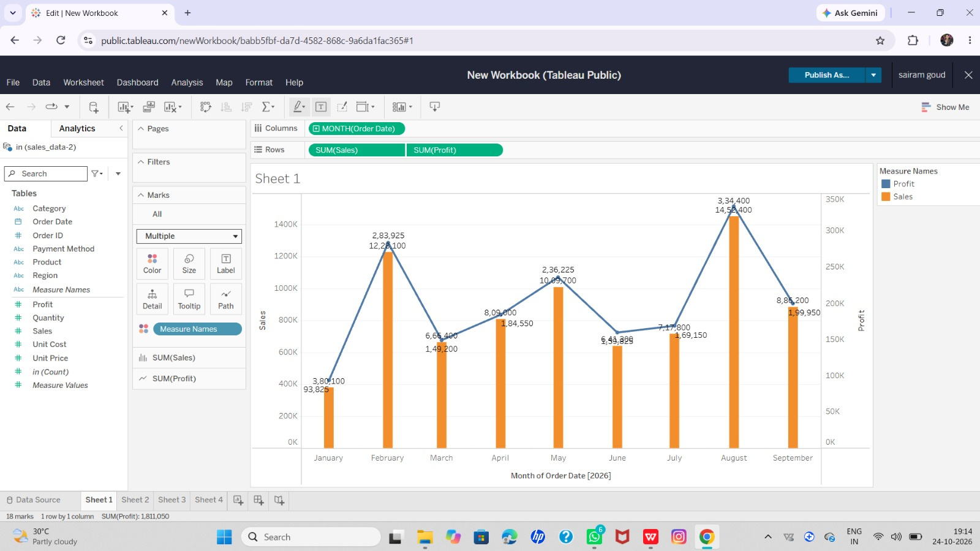
- ​Use the Dual Axis option to combine both bar and line charts into a single view.
​
Sheet 2: Category / Region-wise Sales
​Description: This sheet shows sales across different categories and regions using a bar chart. It helps compare sales performance across various geographic regions and product categories.
​Procedure:
- ​Open a new worksheet.
- ​Drag Category and Region dimensions to Columns.
- ​Drag the Sales measure to Rows to generate the bar chart.
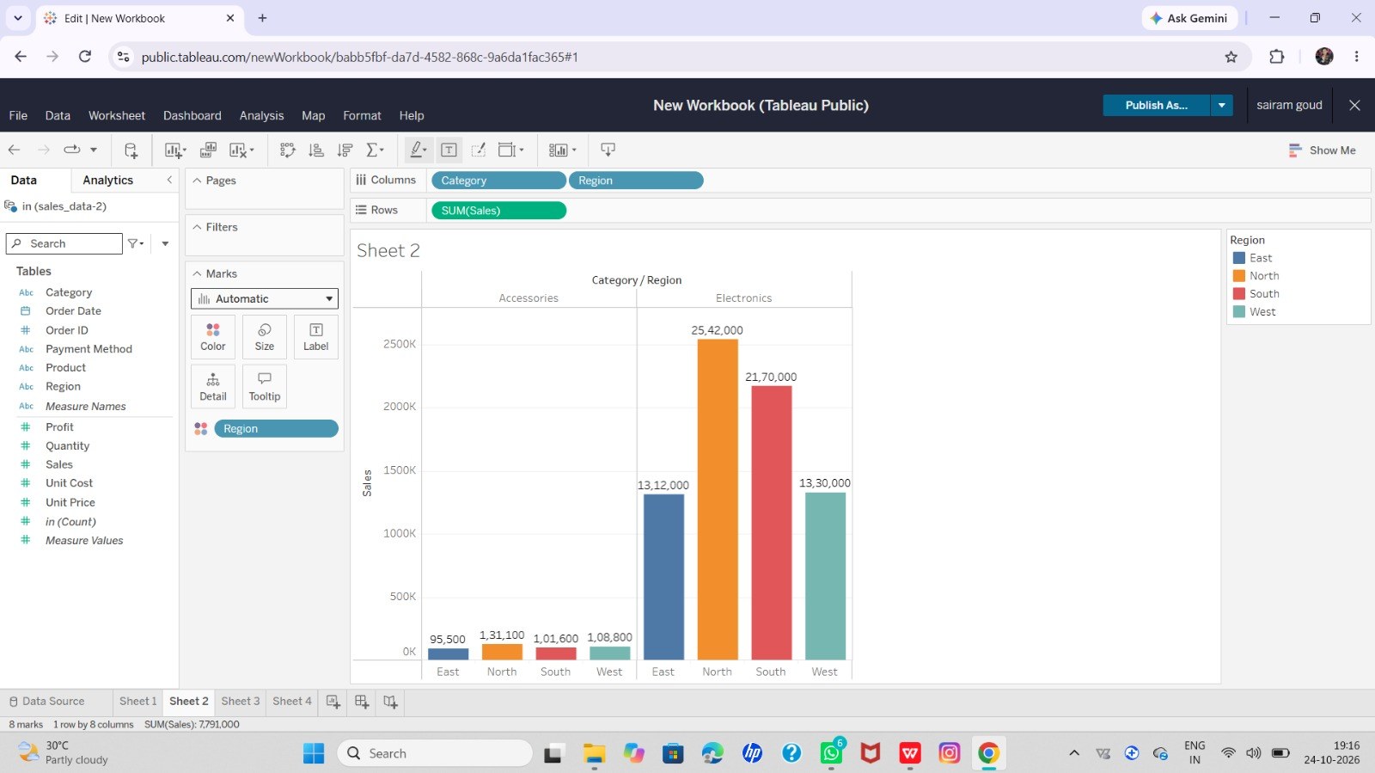
​

Sheet 3: Category-wise Sales
​Description: This sheet represents the total sales of different product categories using a bar chart. It helps easily identify which category generates the highest or lowest sales.
​Procedure:
- ​Open a new sheet and drag Category to Columns.
- ​Drag Sales to Rows and select the bar chart option.

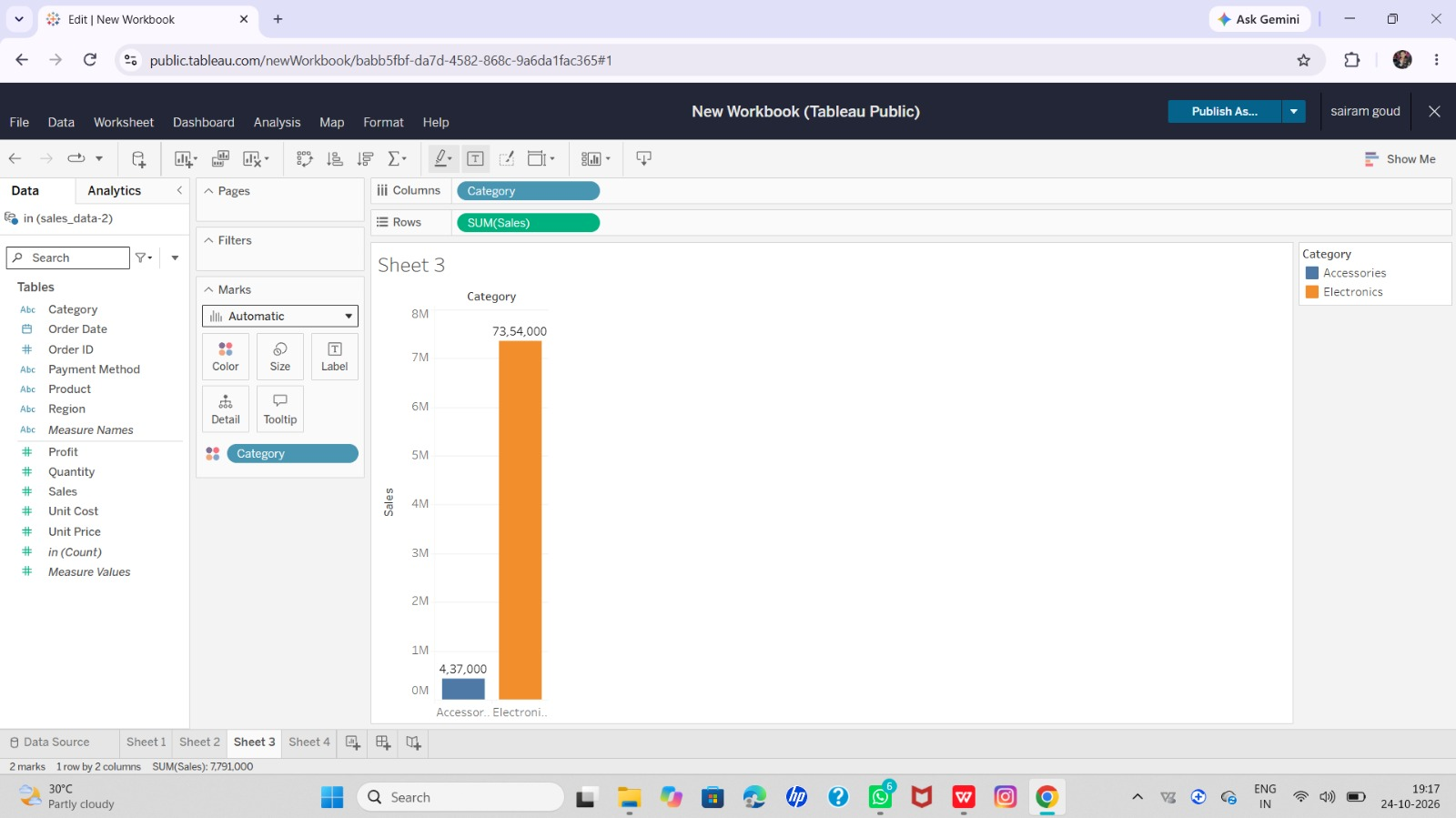
Sheet 4: Category Share (Pie Chart)
​Description: This sheet represents the sales share (contribution) of each product category using a pie chart. It helps understand each category's percentage contribution to overall sales.
​Procedure:
- ​Open a new worksheet.
- ​Select Category and Sales, then choose Pie Chart from the Show Me panel.
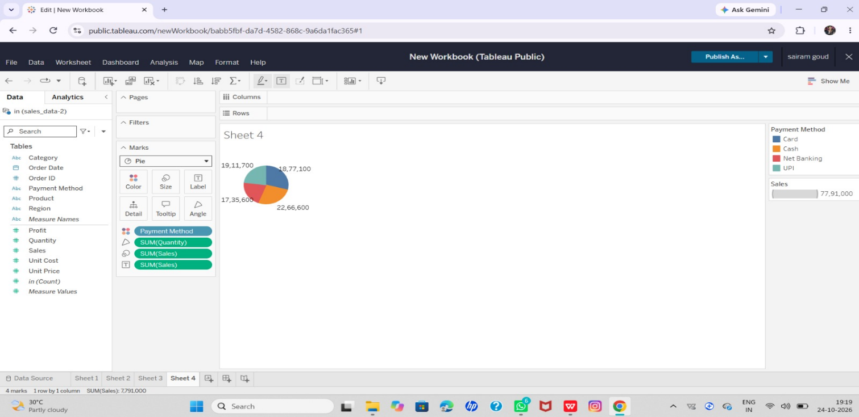
- ​Adjust and fit the chart properly using the view options if necessary.
Dashboard Creation Steps:
- ​Click on the New Dashboard icon at the bottom of Tableau.
- ​From the left-side panel, drag and drop Sheet 1, Sheet 2, Sheet 3, and Sheet 4 properly into the dashboard layout.
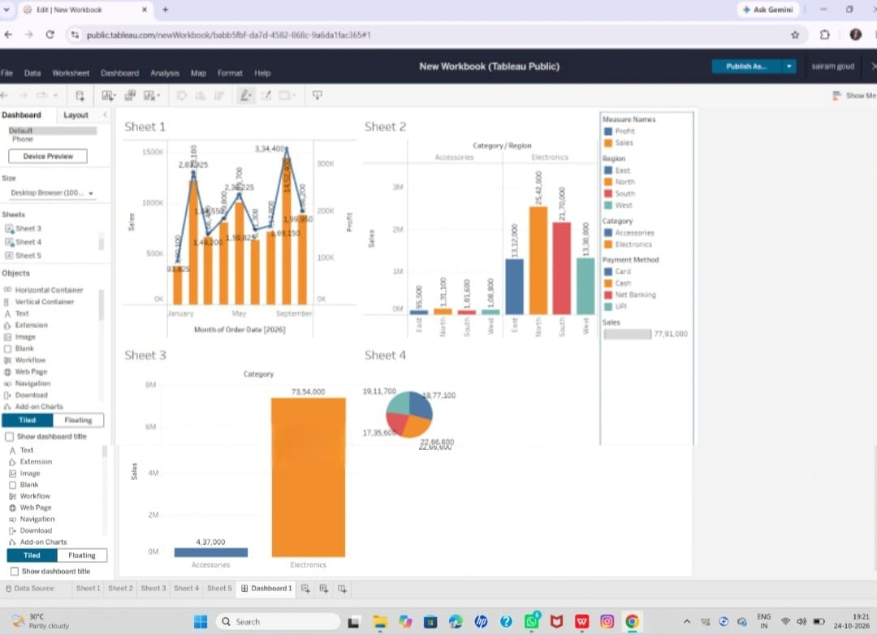
- ​Resize each chart so that all four fit neatly and clearly.

